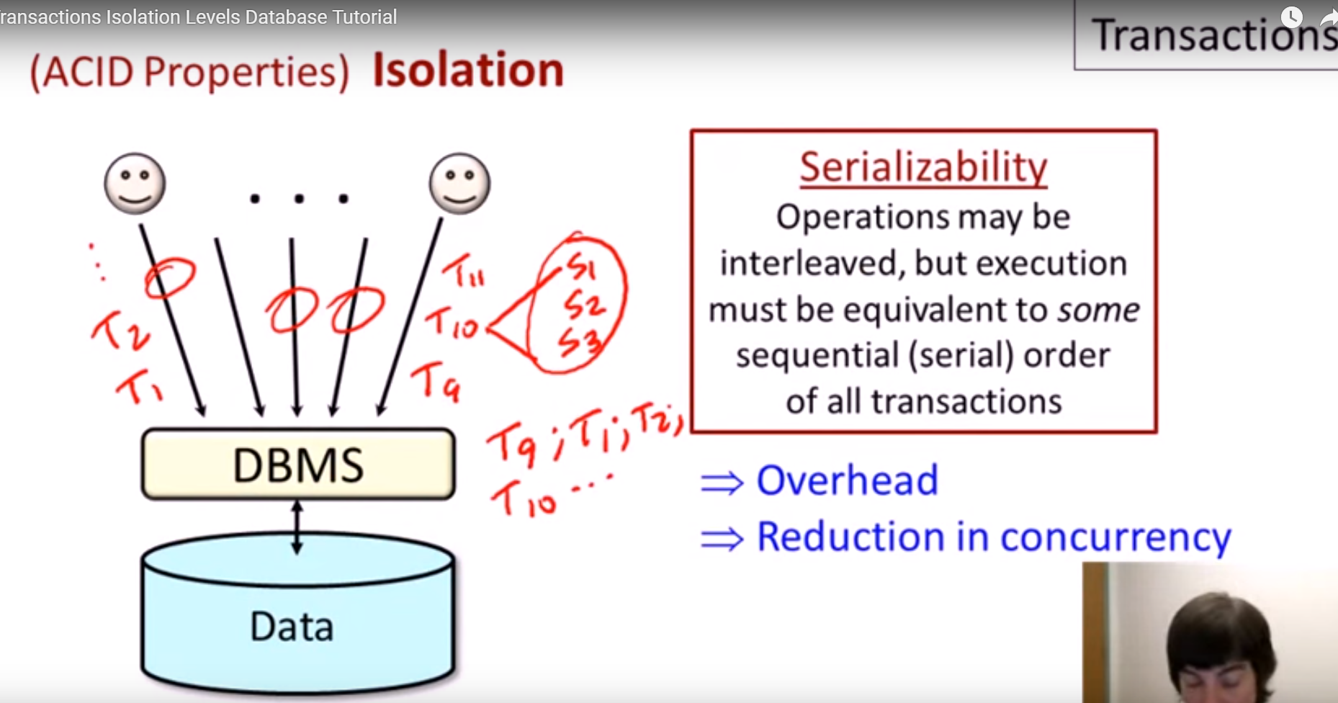

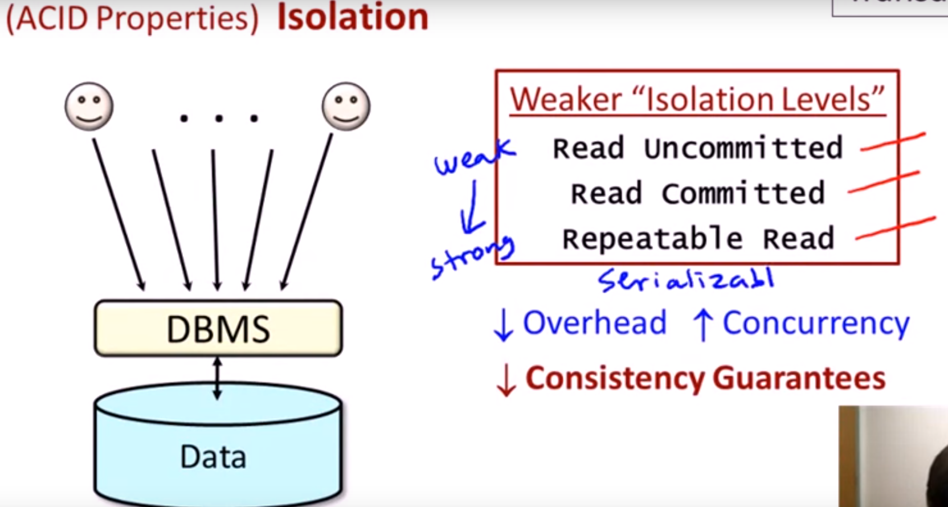

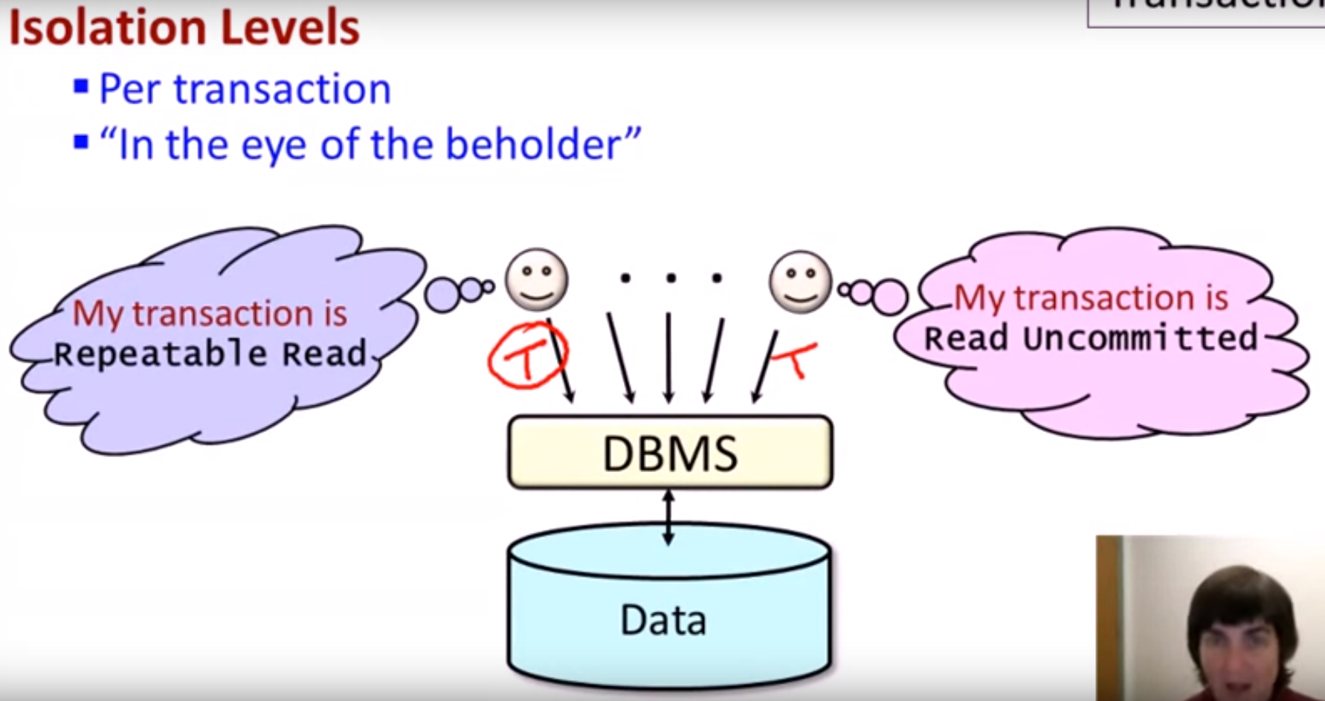

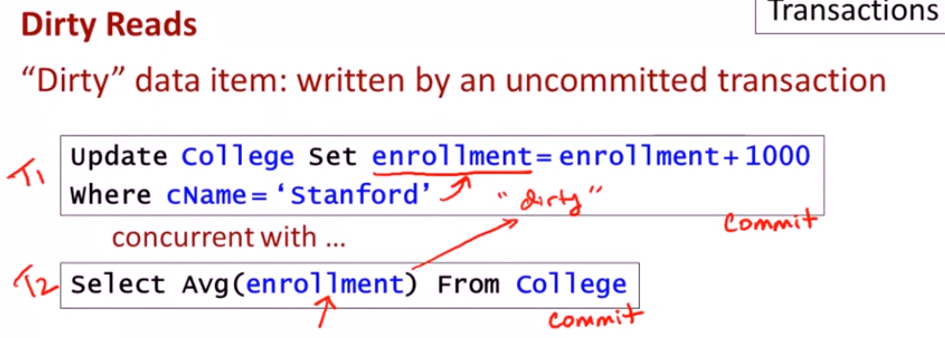

* If T2 read data before T1 commit and T1 fail/rollback , then T2 read is dirty.

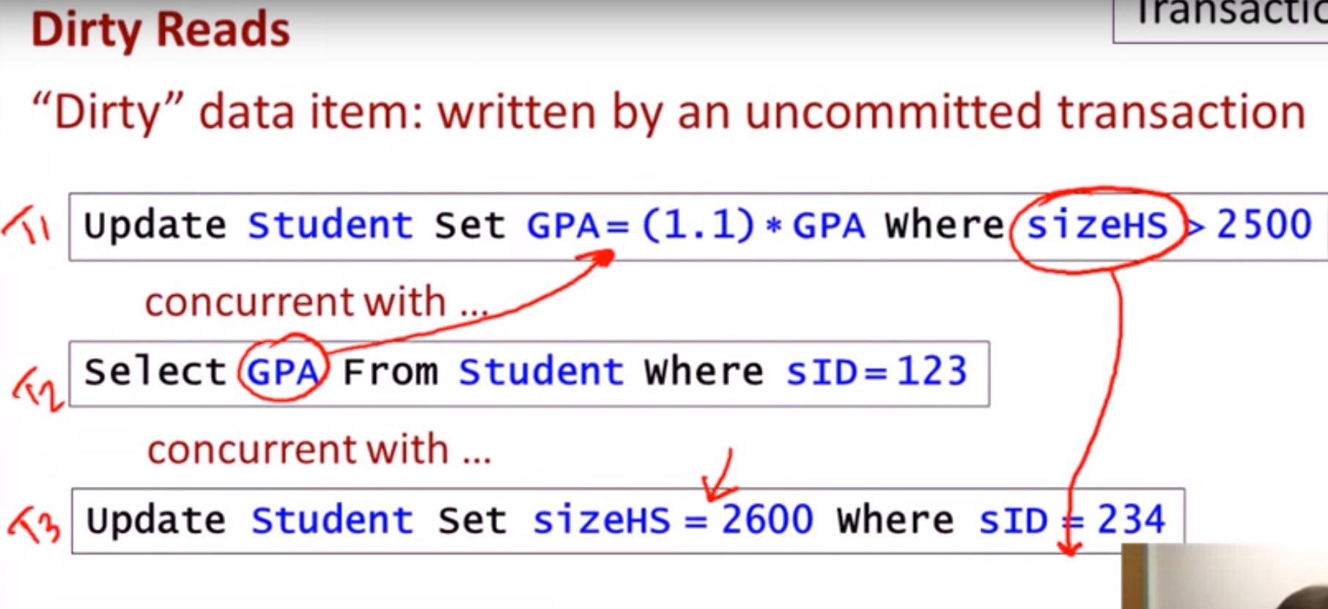

* If T2 or T3 read data before T1 commit and T1 fail/rollback , then T2 read is dirty

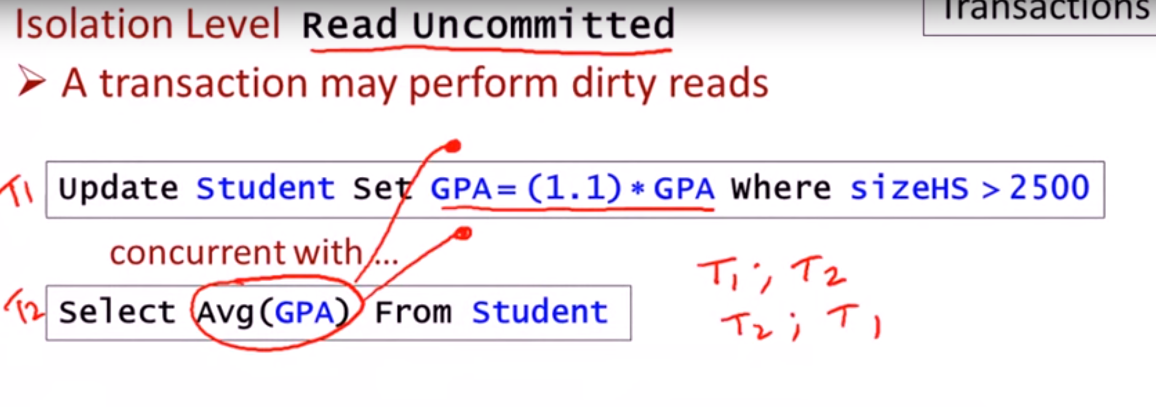

Here order of Transaction can’t be define You can’t say T1 after T2 , T2 after T1.

Here we don’t mind if our avg will be compute with some old value and some new value.

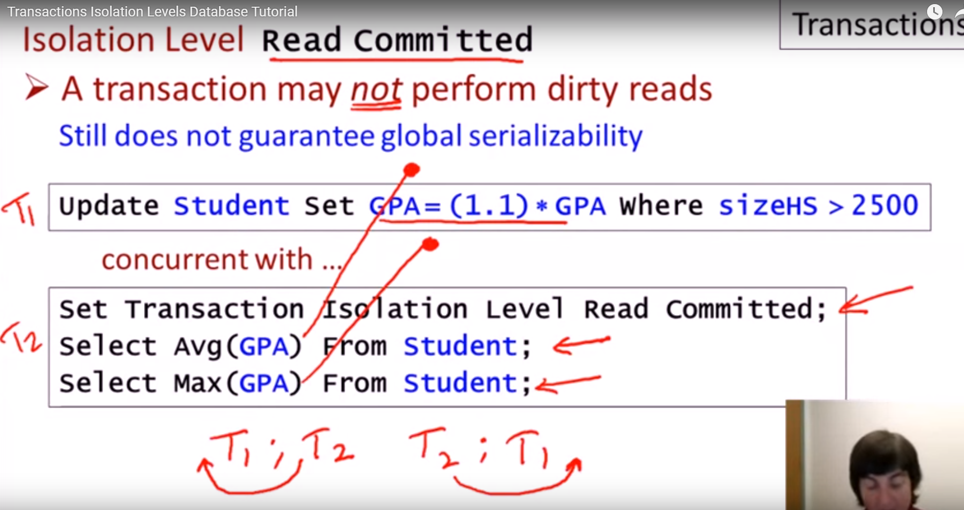

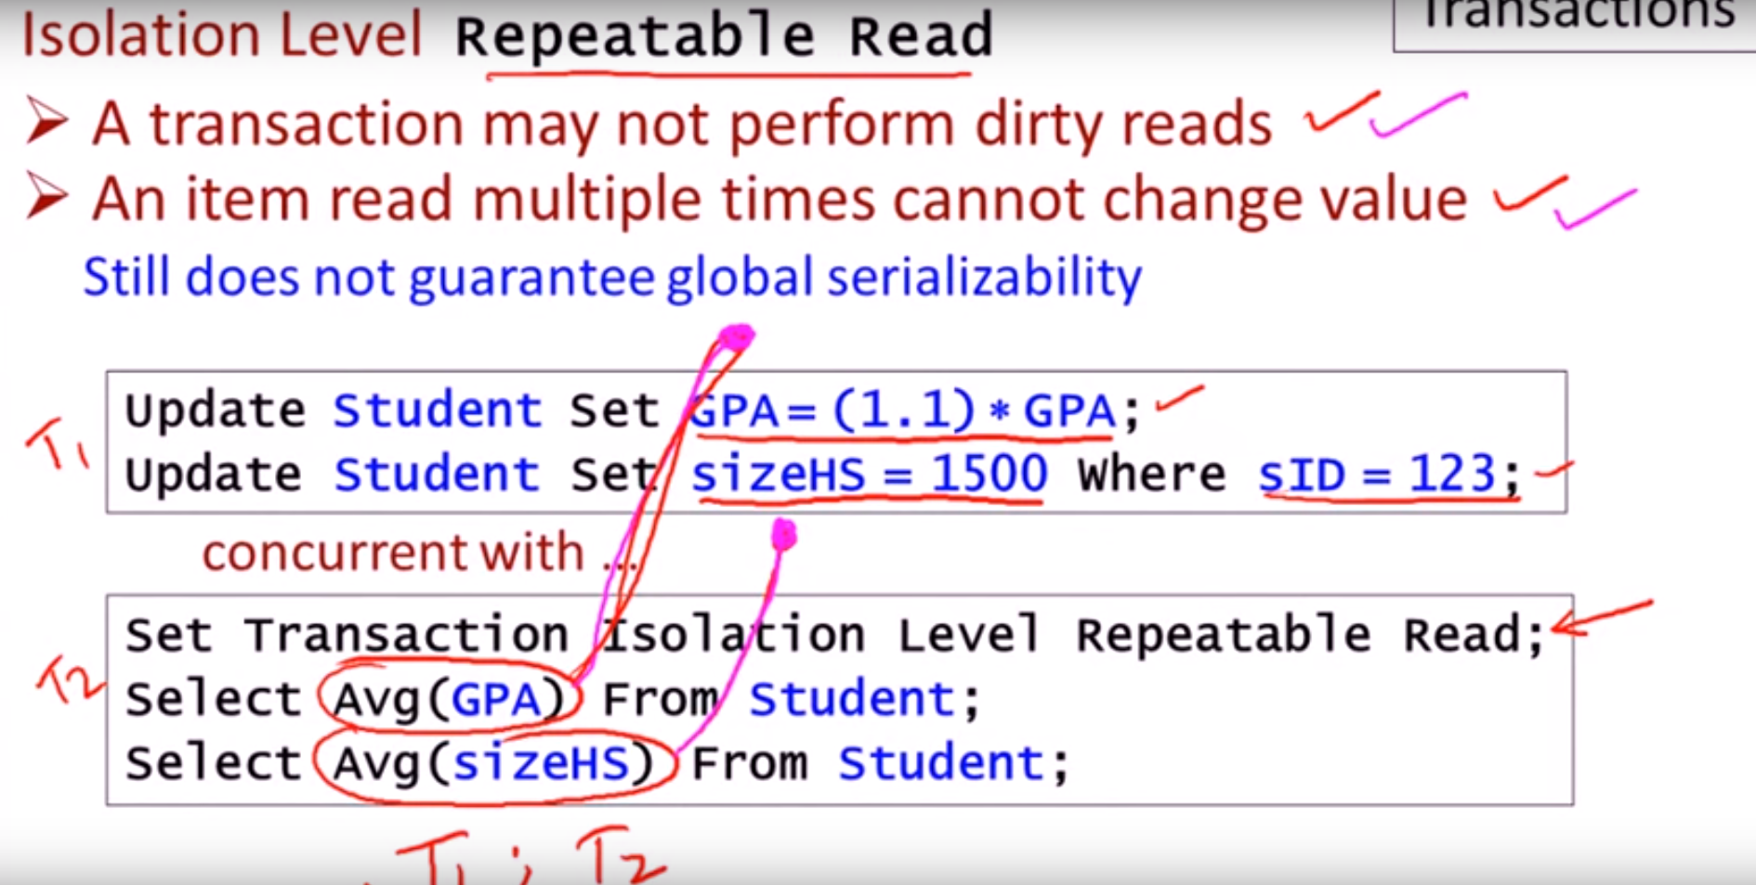

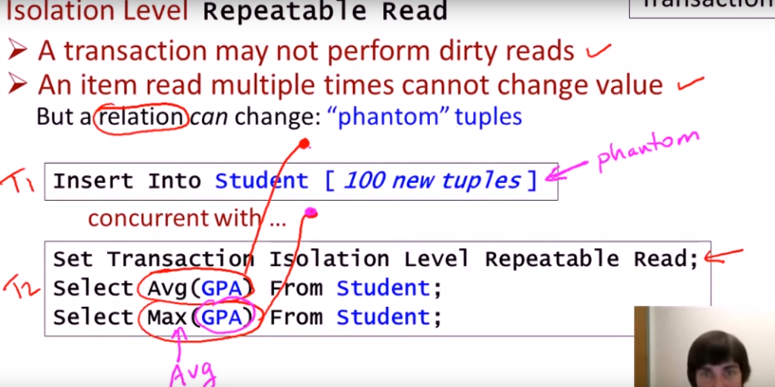

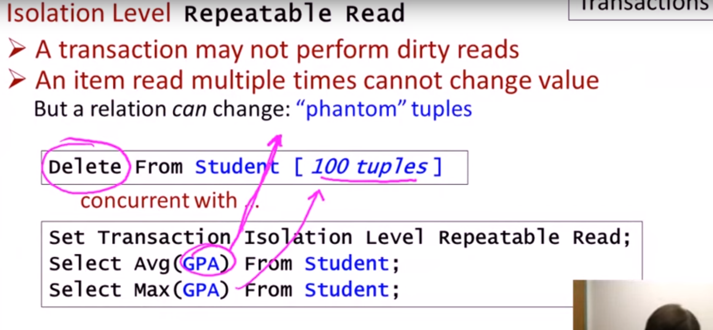

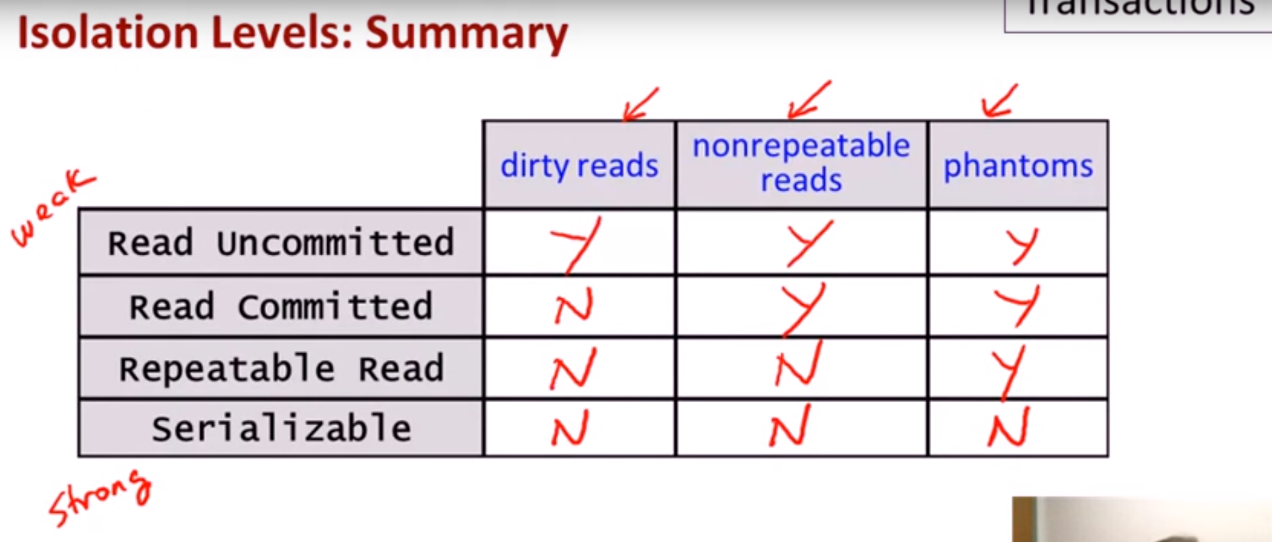

Oracle and MqSql have Repeatable Read as Default.

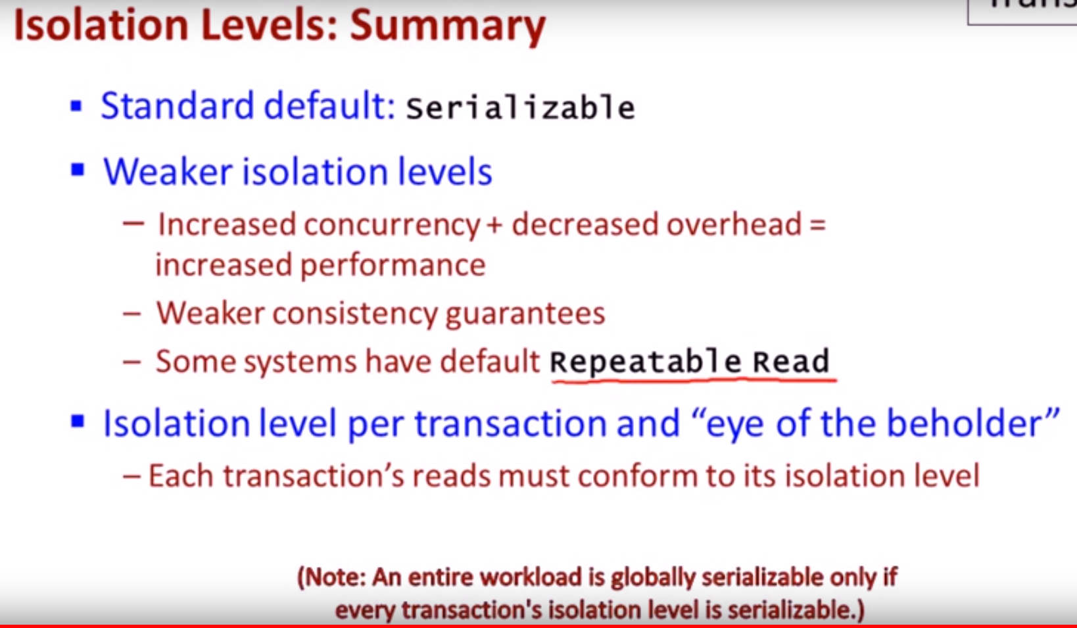

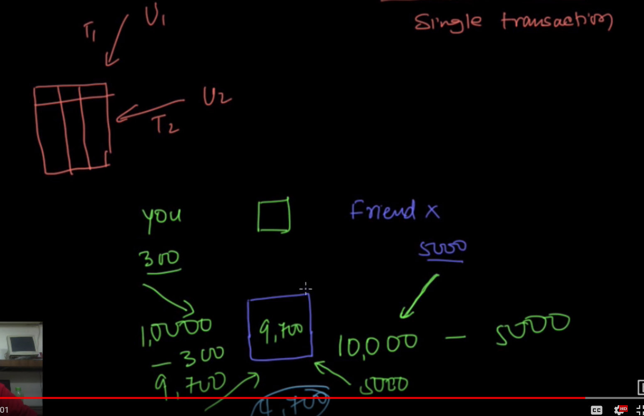

ACID

Atomicity, Constancy, Isolation, Durability

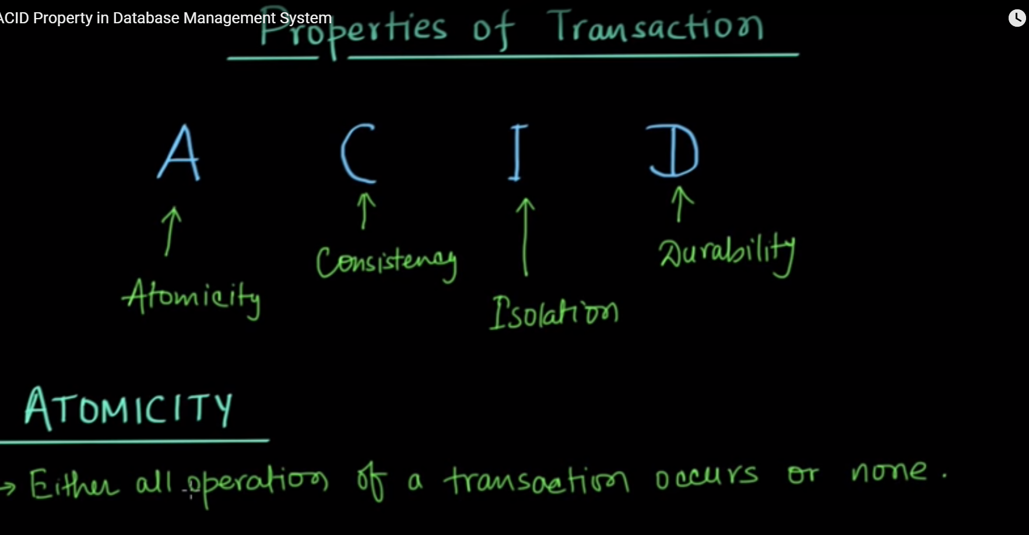

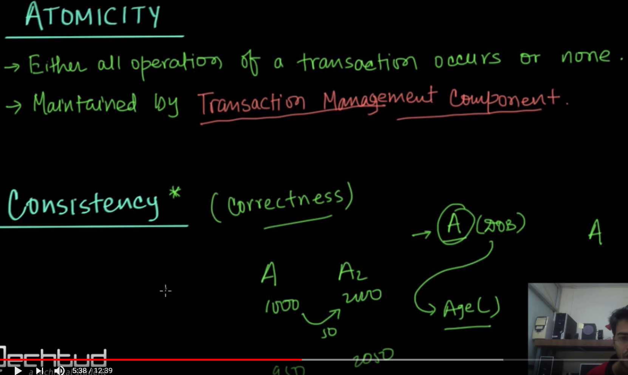

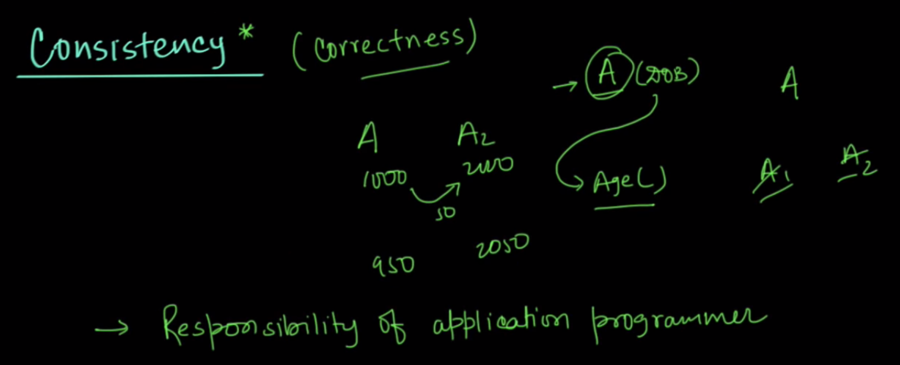

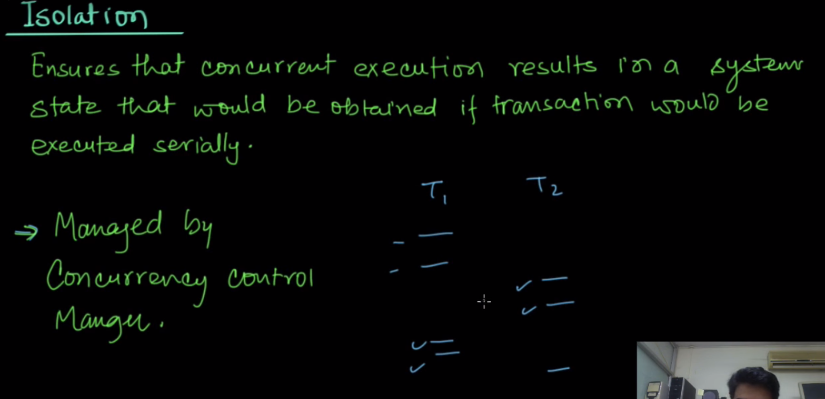

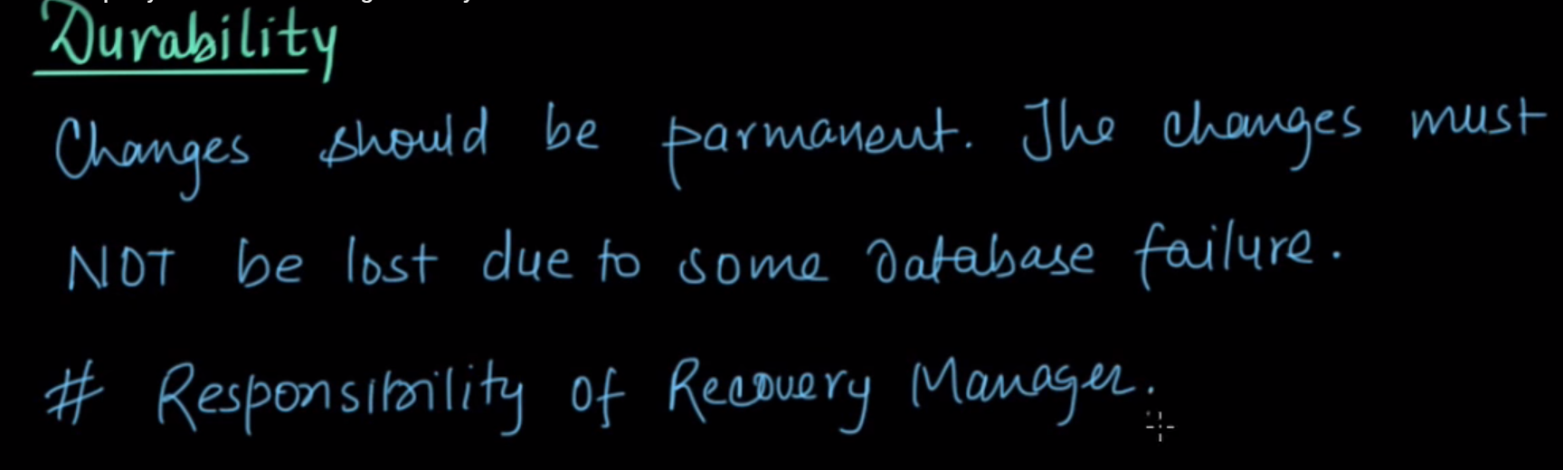

<https://www.youtube.com/watch?v=WyiI6SiSYPk&index=3&list=PLbKVlnc3OmnwG-2-EeoheUZxBHwJhRaZ->

<https://www.youtube.com/watch?v=HcjHJLEbtRs>

<https://www.youtube.com/watch?v=CigdiifWItk>